LAB 1

Part A: VMs vs Containers

- Launching the VM in the terminal
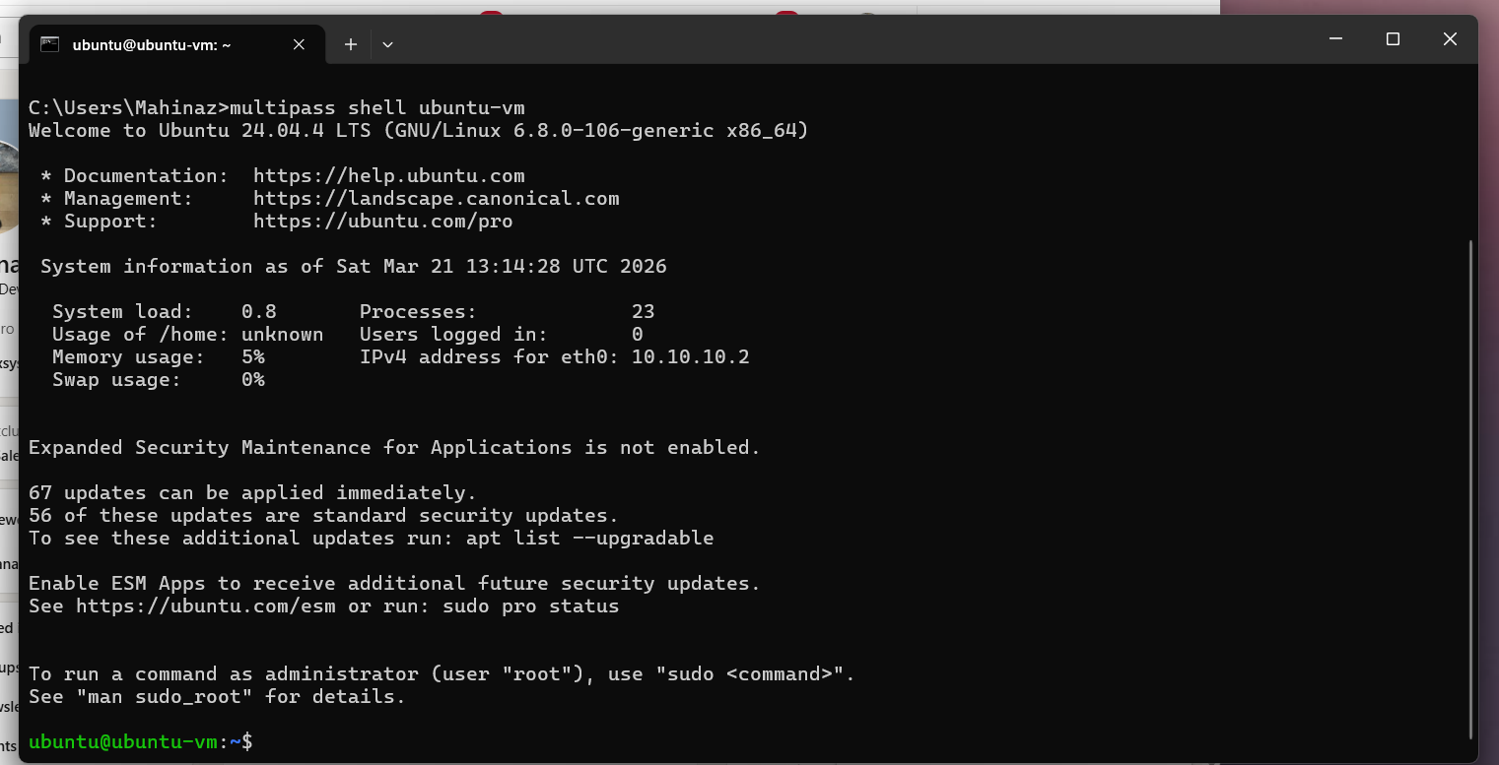

- Checking memory usage
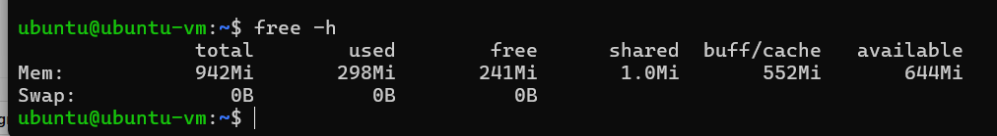

- Checking processes
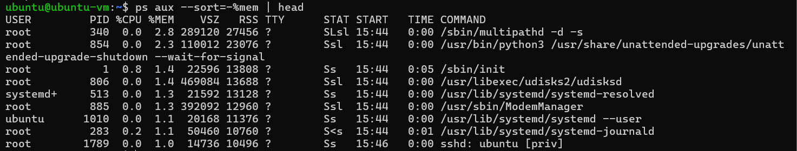

- Checking disk
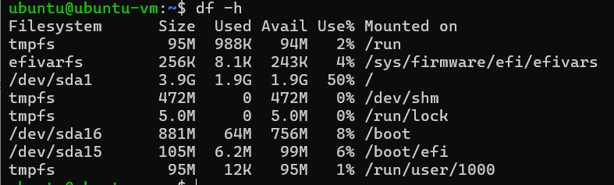

For the container part
- Run the app and then pull the Ubuntu image
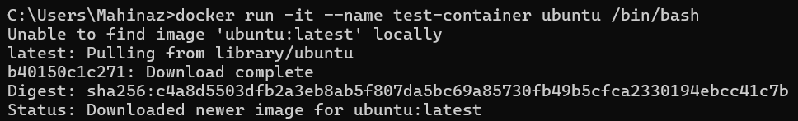

- Check memory usage
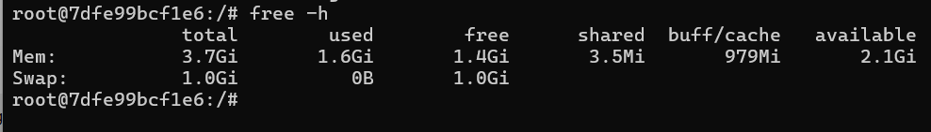

- Check the processes
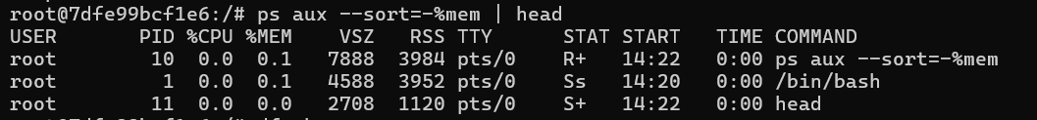

- Checking Disk
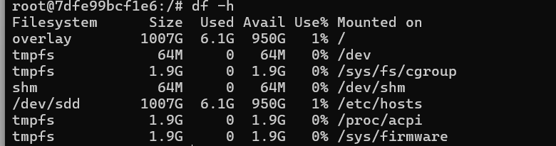

Part B: cloud infrastructure

After opening AWS and launching an EC2 instance and connecting everything the terminal opens and then:
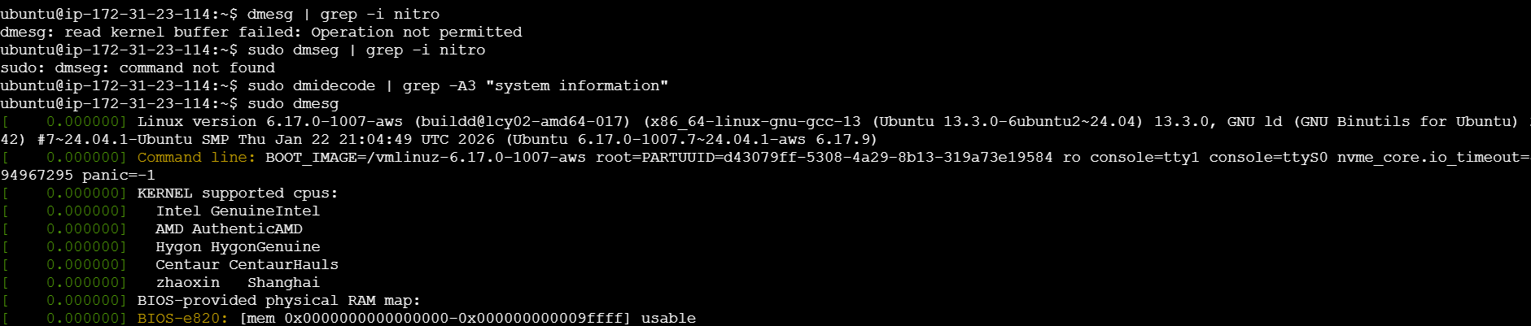
Here shows that nitro is visible but not accessible , it’s hidden

Then adding command top to view the processes
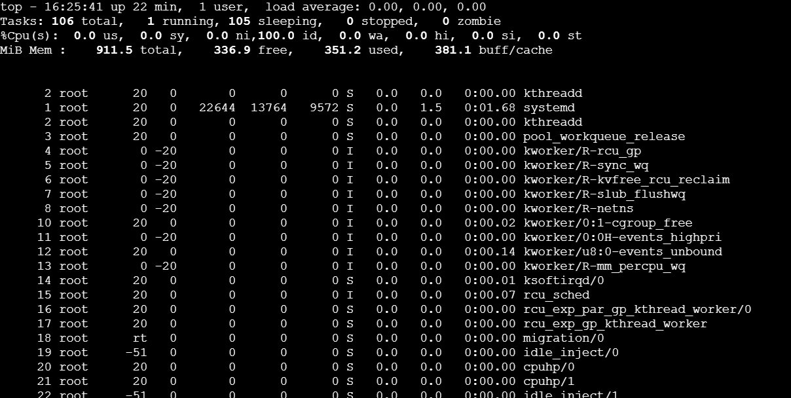

Part C: Tail latency

In the same terminal, create a Flask app
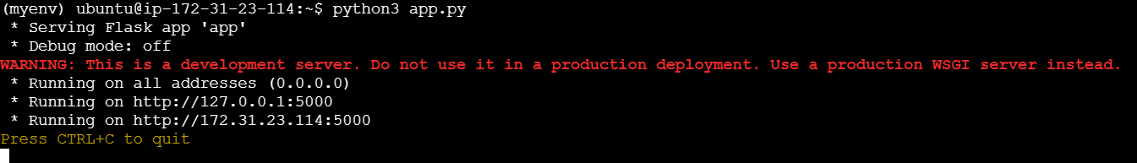
I created a virtual environment so I can run the app on

Opened another terminal in the same instance to test it:
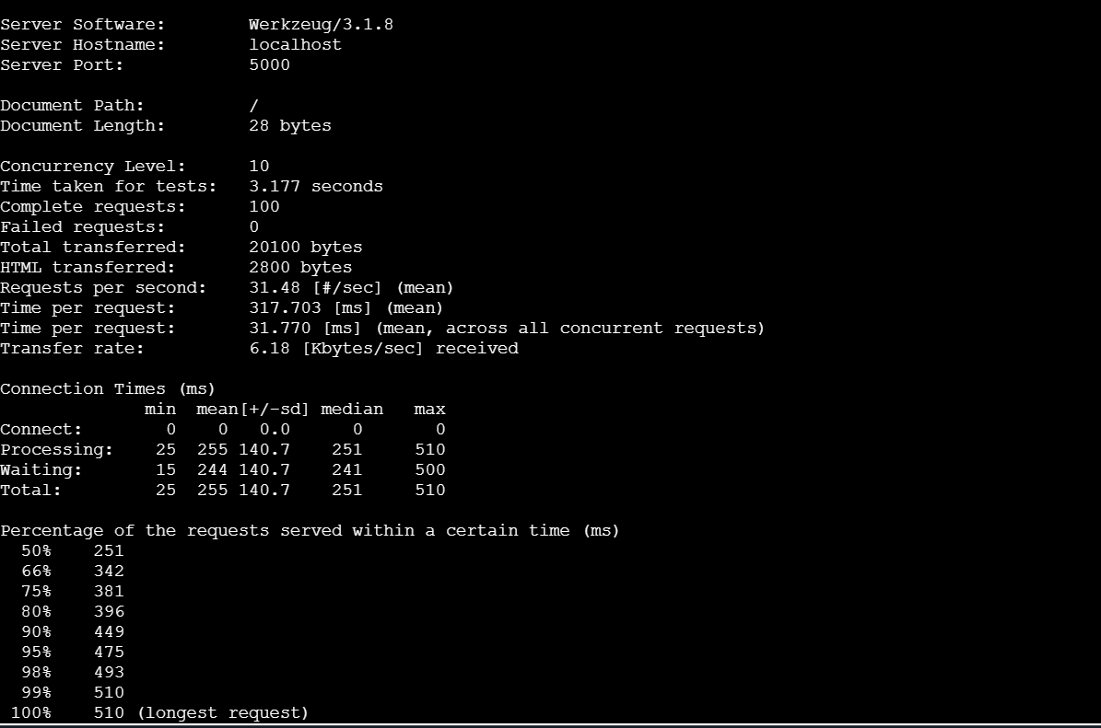

Which architecture (VM or container) is better for microservices? Why?
Containers are generally better for microservices. They’re lightweight, start fast, scale easily, and let you deploy services independently (e.g., with Docker and Kubernetes).
VMs offer stronger isolation but are heavier and slower to scale.

